Online Application Guide

for 2018 Exchange Student Applicants

Before you start your online application

After you have been nominated by your home university coordinator, apply online.
Online Application Period:
March 5th(Mon) 09:00 ~ April 13th (Fri) 23:00, 2018 (Korean Time)

You MUST use the Internet Explorer browser and have your photo and all attachment files prepared in the required format. (jpg or bmp)

You must type in your personal data correctly from the beginning.

Please read the FAQ in detail before emailing your inquiry at orir@inha.ac.kr

International center
INHA UNIVERSITY
Step 1. Register for the Online Application System

- Go to the online system URL
http://itislink.inha.ac.kr/ipsiIExchange/IIE61001/ApplyLoginFGrd.aspx

- Click Register to start your application
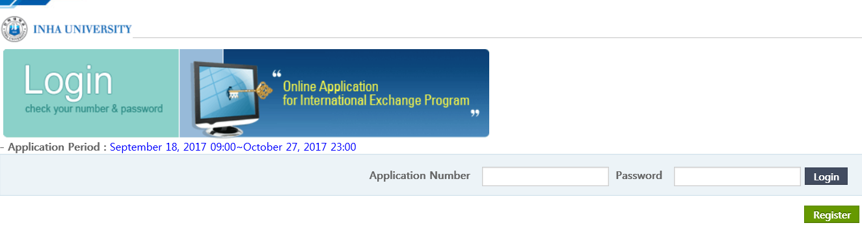
Click to register Register

Step 2. Fill out the (A)Application Section

Leave this [Application Number] blank. You do not need to type anything.
Your application number will pop up automatically at the last stage after submission.
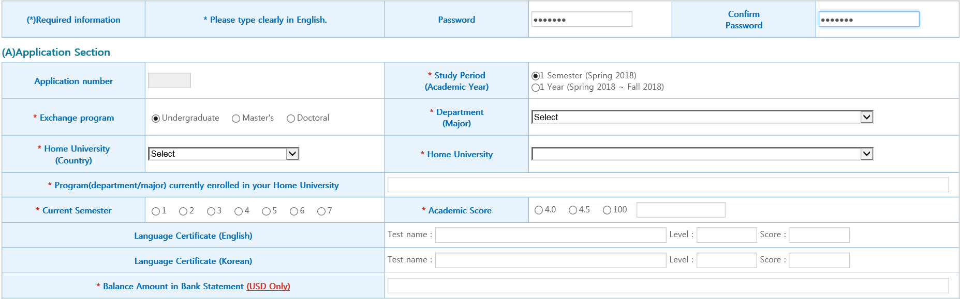
※ Current Semester means the enrolled semester at your home university. (If you are currently in the first semester of your third year, you need to enter in “5”.)
※ Academic Score means your accumulative GPA.
Ex) 3.5/4.0, 4.0/4.5, 90/100

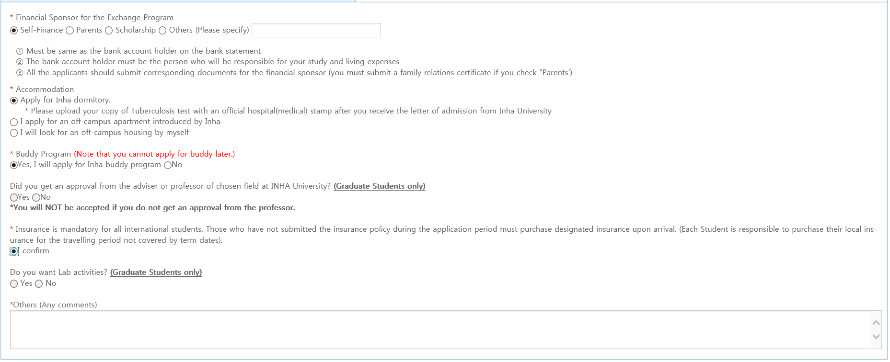
※ Apply for Inha dormitory
It is mandatory for all Inha dormitory applicants to submit an official Tuberculosis test result.
(Tuberculosis Examination Form can be downloaded at the bottom of the page on “Application Documents Download”)
Step 3. Fill out the (B)Biographical Section
Same as in your passport.
(If you have a long middle name, omit it
and you may just write the first name)

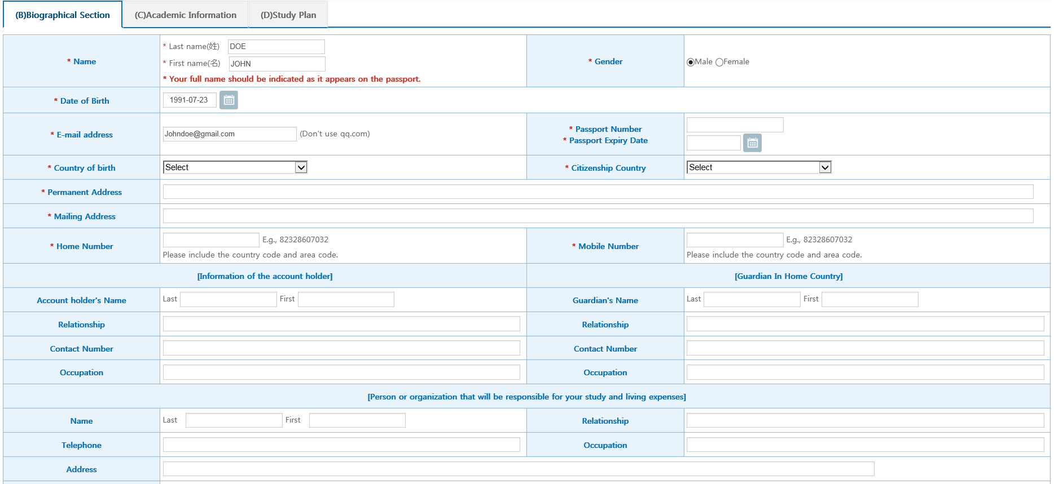

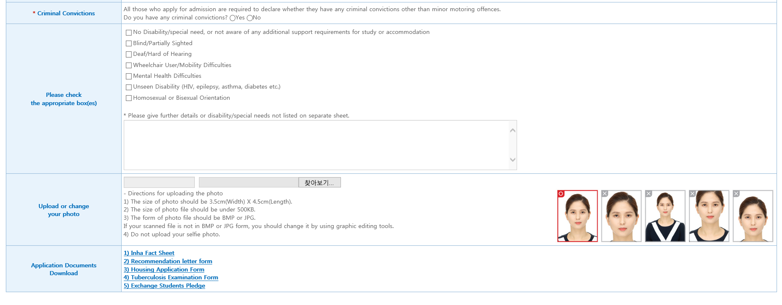
※ The photo you upload on the system will be used for your Student ID Card. (It does not have to be the same photo on your passport)

※
Step 4. Fill out the Remaining Sections

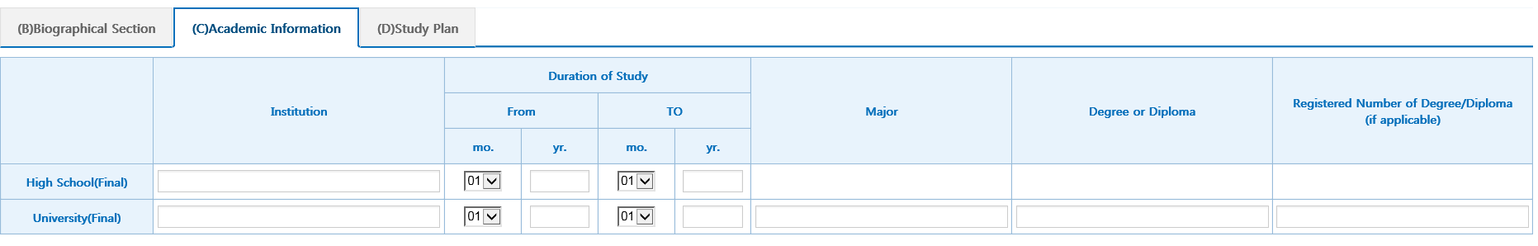

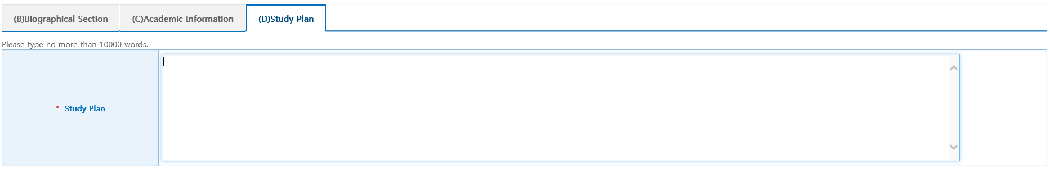
※ Describe the reason you want to study at Inha, and what you want to achieve during your exchange semester in paragraph form.

Read and check “I Agree,” and click submit 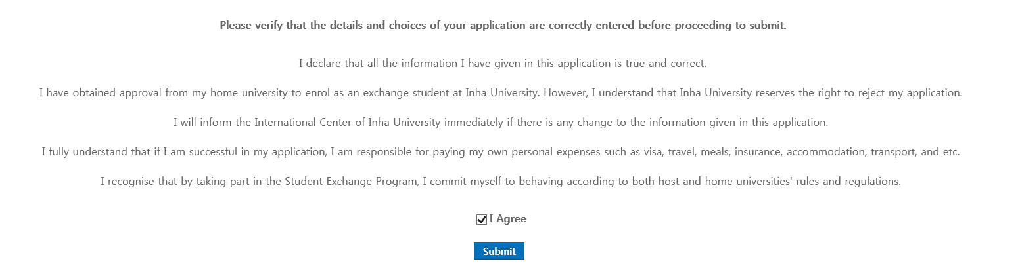

Step 5. Submit your Application

When submission is successfully made, the box will appear with your application number as below.

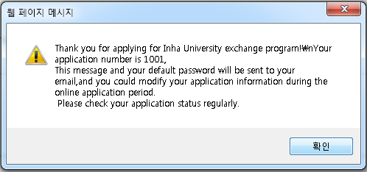

Step 6. Upload Attachments

- Type in your “Application Number” and “Password”
- Do not click “Login”
- Click Upload Attachments
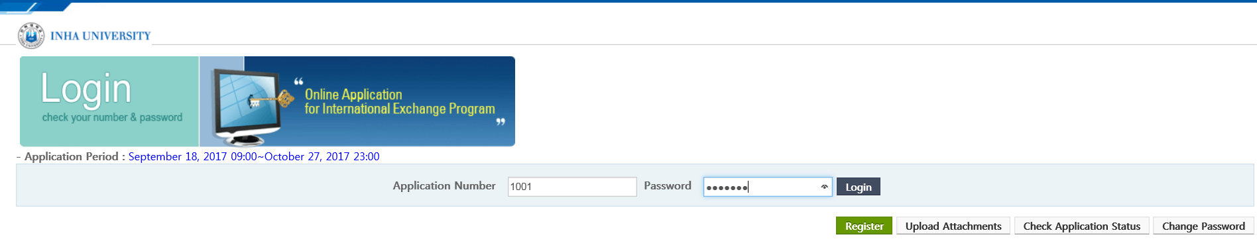

You can download the application document forms by clicking them.
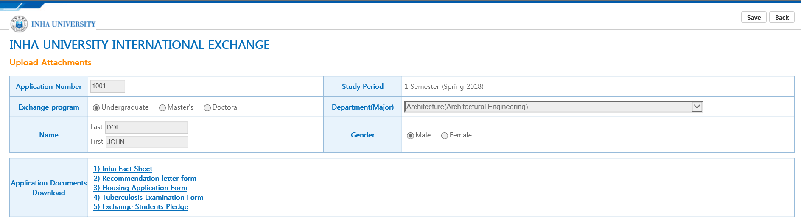

Fill out the application documents and upload your files by clicking this
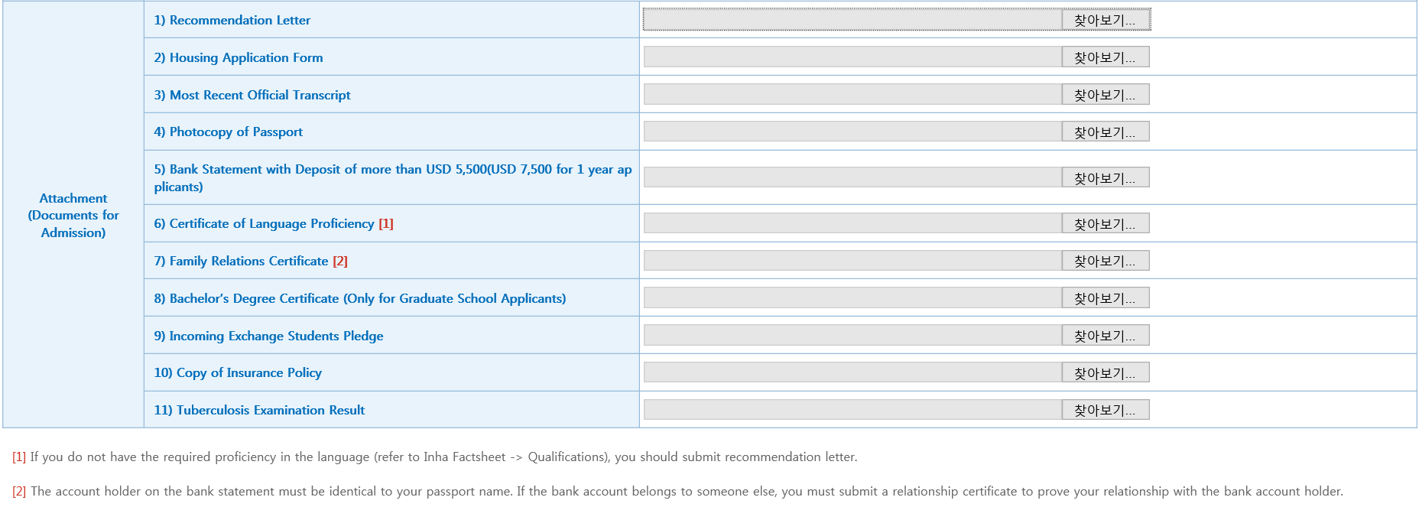
TB Examination Result is mandatory only for those who applied for the Inha dormitory.

Frequently Asked Questions : Online Application

Q. I am in the middle of completing the section. Can I save it?
A. No, you cannot save it. You should start and complete the application in one sitting.

Q. Where can I get attachment file forms such as housing forms?
A. You can download them from our online application system.

Q. I forgot my password. How can I find it?
A. Email us (orir@inha.ac.kr) with your home university and your full name.

Q. What should I include in the Study Plan?
A. Describe the reason you want to study at Inha, and what you want to achieve during your exchange semester.

Frequently Asked Questions: Miscellaneous

Q. Can I apply for the Buddy Program when I arrive in Korea?
A. No you cannot. Apply for the buddy program when you do your online application. Still, you are most encouraged to join our welcome party.

Q. When do I receive the letter of acceptance?
A. The letter of acceptance will be issued during mid-December. It may take longer if you provide us with insufficient or erroneous documents.

Q. I want to live in a 2 or 3-bedroom apartment and share it with my friends. Can the International Center help us?
A. The International Center can only introduce one-room (studio type) apartments. If you plan to live in 2 or 3-bed room, you need to come earlier and find it from real estates on your own.

Q. Can I share a dorm room with a friend or someone from the same country?
A. No, you cannot. Our dormitory allocates rooms according to its own internal regulations.

Q. Can I extend my staying from 1 semester to 1 year upon the arrival?
A. Sure. If your home university officially requests, you can shorten or extend your staying at Inha. You need to extend your visa though. (Extension Fee: Around KRW 70,000)

Q. I am an undergraduate student. Can I take courses from the graduate course?
A. No, you cannot. Cross-registration is not permitted except for a few courses for Architecture majors.

Q. I may arrive few days later than the proposed arrival date. What should I do?
A. Please inform us at least 2 weeks in advance. If you miss welcome orientation, we will tell you what you need to do on your own. (ex. Applying for alien registration card, paying for the housing etc.)

Q. Can I live in Seoul and commute to Incheon?
A. Yes, it is up to your decision. If you live in Seoul, you need to make an alien registration card at Seoul immigration office, not at Incheon. Please inquire this matter to International Office once again, upon your arrival.

